PROG2002 - Web Development II
Assignment 2: Use Case (A Dynamic Website)

Student ID: 24832407
Last Name: Liu
First Name: Boyu
Title of the project: Hearts United - A Dynamic Charity Events Website

Live demonstration: index.html (Home), search.html (Search Events) and event.html (Event Details), backed by the Node.js/Express REST API and the MySQL database charityevents_db. The website is built with HTML, CSS and plain JavaScript (DOM, Fetch, Promises) only - no CSS or JavaScript frameworks and no server-side templating are used.

1. Introduction/Motivation
Charity events such as gala dinners, fun runs, silent auctions and concerts are the main way local non-profit organisations raise money and awareness for their causes. In the given case study, the public needs to be able to view the details of these events and to register their participation (purchasing tickets as donations). Today most of this information is spread over printed flyers, social media posts and phone calls, which makes it hard for supporters to find events that match their interests and schedule.
The motivation for this project is to give the charitable organisation one professional, always up-to-date online home for its events. A single dynamic website lets supporters discover events, filter them by their own criteria, read the full story behind each cause and see how much of the fundraising goal has already been reached. On the technical side, the project is also a practical demonstration of how client-side and server-side web technologies work together: a MySQL database stores the data, a Node.js/Express REST API serves it as JSON, and a pure HTML/CSS/JavaScript client consumes that API and renders it in the browser.

2. Problem Statement
The charity organisation currently has no dynamic system for managing and promoting its events. This creates the following problems:
- Information is scattered across different channels, so supporters cannot see all current and upcoming events in one place, and cancelled or out-of-date listings stay visible.
- Supporters have no way to search. A family looking for "a free family event in Southport this month" has to read every flyer and web page manually because there is no filtering by date, location or category.
- There is no control over the content that is published. An event that violates the organisation's policy (for example, an unlicensed fundraiser) could still be advertised to the public.
- The impact of a donation is invisible. Without a goal-versus-progress view, donors cannot see how close an event is to its fundraising target, which reduces motivation to give.
- The organisation has no technical staff, so any solution has to be simple to set up, simple to maintain, and must not depend on paid third-party services.

3. Solution
The problem is solved with a three-tier client-server web application. The tiers are deliberately separated so that each one has a single responsibility.

3.1 Architecture
- Data layer - MySQL database "charityevents_db" with three related tables (organisations, categories and events). The Node.js file event_db.js creates a connection pool and is the only part of the application that talks to MySQL.
- Application layer - a Node.js + Express REST API (server.js). It exposes intuitive, resource-based URLs that return JSON. All data access uses parameterised SQL statements, and every endpoint validates its input before querying the database.
- Presentation layer - a client-side website built with HTML, CSS and plain JavaScript. It has no direct database access and no server-side templating; every page is a normal HTML file that calls the API with the Fetch API and renders the returned data into the DOM using Promises.
This separation keeps the database credentials on the server (security), means the same API can be reused by future clients, and makes the project easy to extend in Assessment 3 - registration and the admin side only require new API endpoints (POST/PUT/DELETE) and small additions to the pages.

3.2 How the client and the server communicate
The data flow for the home page is: (1) the browser requests index.html and its CSS/JS files from the static client site; (2) home.js calls fetch(API_BASE + "/api/events") using a shared helper that returns a Promise; (3) the Express route /api/events executes a parameterised SELECT with the mysql2 connection pool from event_db.js; (4) MySQL returns the rows, which Express serialises as a JSON array; (5) the JavaScript receives the JSON in the .then() handler, loops over the events and builds the event cards using DOM methods, inserting them into the page. Any failure - for example the API server is not running, or a 404 is returned for an unknown event - is caught in the .catch() handler and displayed to the user in a message box, again through DOM manipulation.
Because the event details page must show one specific event, the event id is passed between pages in the URL query string (event.html?id=4). event.js reads it with URLSearchParams, validates that it is numeric, and only then calls /api/events/4. This keeps links shareable and bookmarkable.

4. Web UX
Before writing any code I sketched a simple wireframe for each of the three pages and then followed those sketches during development. The aim was that a first-time visitor can find an event and understand its cause without any instructions.

4.1 Navigation and structure
- A sticky top menu with the same two links (Home, Search Events) appears on all three pages, with the current page highlighted, so users never get lost. Every page also has a consistent header, footer and colour scheme.
- The home page follows the classic charity-event pattern: hero with the mission and a call to action, a short mission/contact band, and then the dynamic list of current and upcoming events.
- Each event card is a summary view showing exactly the data a person needs to decide whether to click: illustration, category badge, event name, date and time, location and venue, a fundraising progress bar, the ticket price and a "View details" link to the details page.
- The events details page uses a two-column layout: the story of the event and its cause on the left, and the practical details (when, where, ticket) plus the goal-versus-progress bar and the Register button on the right, where they are easy to find.

4.2 Search experience
- The three criteria use the input control that best matches the data: a date picker for the date, a free-text field for the location (so partial matches such as "south" work), and a dropdown for the category, which is populated dynamically from the database via /api/categories.
- Any combination of the three criteria can be used. The page sends only the criteria that were filled in as query parameters, and the results appear in the same card format as the home page, each with a link to its details page.
- The "Clear Filters" button resets every field and removes the previous results and messages, which demonstrates basic DOM manipulation.
- Validation is done twice: the client checks that at least one criterion was chosen and that the date is not in the past, while the API re-validates the date format, the category and the length of the location text. Error messages are shown in an accessible message box rather than with alerts, so the user keeps their context.

4.3 Feedback, accessibility and responsiveness
- Every asynchronous action shows a loading state, and an empty result set shows a friendly message instead of a blank page.
- Labels are attached to all form controls, images have alt text, result regions use aria-live, the Register dialog can be closed with the Escape key or by clicking the backdrop, and colour contrast is kept high.
- The layout is responsive: CSS grid and a small number of media queries turn the three-column form and the two-column details page into a single column on small screens.
- The illustrations are local SVG files, so the site does not depend on any external image hosting or CSS/JavaScript framework.
For Assignment 2 the "Register" button intentionally does not collect payment. Clicking it opens a modal dialog which states that "This feature is currently under construction." - the registration and ticket purchasing workflow is the scope of Assessment 3.

5. Data Schema
The database "charityevents_db" contains three tables. A separate organisations table avoids duplicating the host organisation's details for every event, and a separate categories table makes the event categories reusable for the search filter.
Table | Main columns | Purpose
organisations | org_id (PK), org_name, mission, description, email, phone, address, founded_year | Stores the charitable organisation that hosts the events, including the contact details shown on the home page.
categories | category_id (PK), category_name (UNIQUE), description | Event types (Fun Run, Gala Dinner, Silent Auction, Concert, Community Festival) used to classify events and to populate the search dropdown.
events | event_id (PK), event_name, event_date, end_date, location, venue, description, purpose, ticket_price, goal_amount, raised_amount, image_url, org_id (FK), category_id (FK), is_suspended, created_at | Stores every charity event. event_date/end_date decide whether an event is past or upcoming, is_suspended hides policy-violating events, ticket_price 0.00 means a free event, and goal_amount/raised_amount drive the progress bar.

5.1 Relationships
- organisations 1 : N events - one organisation hosts many events; events.org_id is a foreign key referencing organisations.org_id.
- categories 1 : N events - one category classifies many events; events.category_id is a foreign key referencing categories.category_id.
- Both foreign keys are enforced by the database, so an event can never reference an organisation or category that does not exist.

5.2 Design decisions and sample data
- The tables are normalised (third normal form): organisation details and category names are stored once and referenced by key, which avoids update anomalies.
- "Past" and "upcoming" are not stored as a column. They are calculated from event_date compared with NOW(), so the data never becomes inconsistent with the calendar; is_suspended is the only manually controlled status.
- DECIMAL is used for all money columns so that no rounding errors occur, and the currency-free format keeps the schema reusable.
- The database is seeded with 3 organisations, 5 categories and 10 events - 8 current or upcoming, 2 already past and 1 suspended - which satisfies the requirement of at least 8 sample events and gives the website realistic data. Dates are inserted relative to CURDATE() so the mix of past and upcoming events is always realistic whenever the SQL file is imported.
- The database is exported to charityevents_db.sql and included in the submission so the marker can recreate it in one step.

6. API Design
The API follows REST principles: every URL identifies a resource, the HTTP method expresses the operation, and responses are JSON with meaningful HTTP status codes. All endpoints in this assessment read data, so all of them use GET - GET is safe and idempotent, can be cached and can be tested directly in a browser or Postman. POST, PUT and DELETE are deliberately left for Assessment 3, where registration and administration are added.
Method | Endpoint | Purpose / parameters | Returns
GET | /api/events | Home page: all current and upcoming events. No parameters. | 200 - JSON array of events (with category and organisation names), ordered by date.
GET | /api/events/search | Search page: filter active events. Optional query parameters date=YYYY-MM-DD, location=text, categoryId=number, combined with AND. | 200 - JSON array of matching events; 400 if a parameter is invalid.
GET | /api/events/:id | Event details page: full details of one event. Path parameter id must be numeric. | 200 - JSON object of the event; 400 for an invalid id; 404 if unknown or suspended.
GET | /api/categories | Search page dropdown: all event categories. No parameters. | 200 - JSON array of categories (id and name).

6.1 A single endpoint in detail: GET /api/events/search
Purpose: return the active (non-suspended) charity events that match the criteria the user selected on the search page. It is the endpoint that powers the core discovery feature of the website.
Request: the parameters are sent in the query string, which is the REST convention for filtering a collection. All of them are optional, and whatever is provided is combined with AND logic:
- date=YYYY-MM-DD - matches events that start on that day (DATE(event_date) = ?).
- location=text - case-insensitive partial match against the city and the venue name (LIKE %text%).
- categoryId=number - matches events of that category (category_id = ?).
Example request: GET http://localhost:3000/api/events/search?location=south&categoryId=1
Response body (200 OK, shortened):
[ { "event_id": 1, "event_name": "Hope City Fun Run 5K", "event_date": "2026-10-11T08:00:00.000Z", "location": "Southport", "venue": "Broadwater Parklands, Southport", "ticket_price": "35.00", "goal_amount": "50000.00", "raised_amount": "31200.00", "category_name": "Fun Run", "org_name": "Hearts United Foundation" } ]
Response body when a parameter is invalid (400 Bad Request):
{ "error": "Invalid date format. Expected YYYY-MM-DD." }

6.2 REST and security considerations
- The URL structure is resource-based and readable: /api/events is the collection, /api/events/4 is one item of that collection, and /api/events/search is a filtered view of the collection.
- Every query is a parameterised statement executed through a prepared statement in mysql2 (query(sql, params)), so user input can never be concatenated into SQL - the endpoints are not vulnerable to SQL injection.
- Input is validated on the server, not only in the browser: the date must match YYYY-MM-DD, the id and the categoryId must be numeric, and the location text is length limited. Invalid input is rejected with 400 before any query runs.
- Suspended events are filtered out in the SQL of every public endpoint (is_suspended = 0) and the details endpoint answers 404 for them, so a policy-violating event can never be exposed by guessing its URL.
- Internal errors return a generic 500 message and are logged on the server only, so database details are not leaked to the browser.
- The API sets CORS headers (Access-Control-Allow-Origin, Access-Control-Allow-Methods: GET) so the static client pages are allowed to call it from another origin, and the client website contains no database credentials at all.

6.3 Testing
- GET /api/events returned the 8 current/upcoming events while the 2 past events and the suspended event were correctly excluded.
- GET /api/events/search?categoryId=1 returned exactly the 2 Fun Run events; adding location=Southport narrowed the result further, and a search with no criteria returned the 10 active events.
- Invalid input was verified: date=banana returned 400, /api/events/abc returned 400 and the suspended event id returned 404.

7. Screenshots
Home page - static organisation content plus the dynamic list of current and upcoming events loaded from GET /api/events:
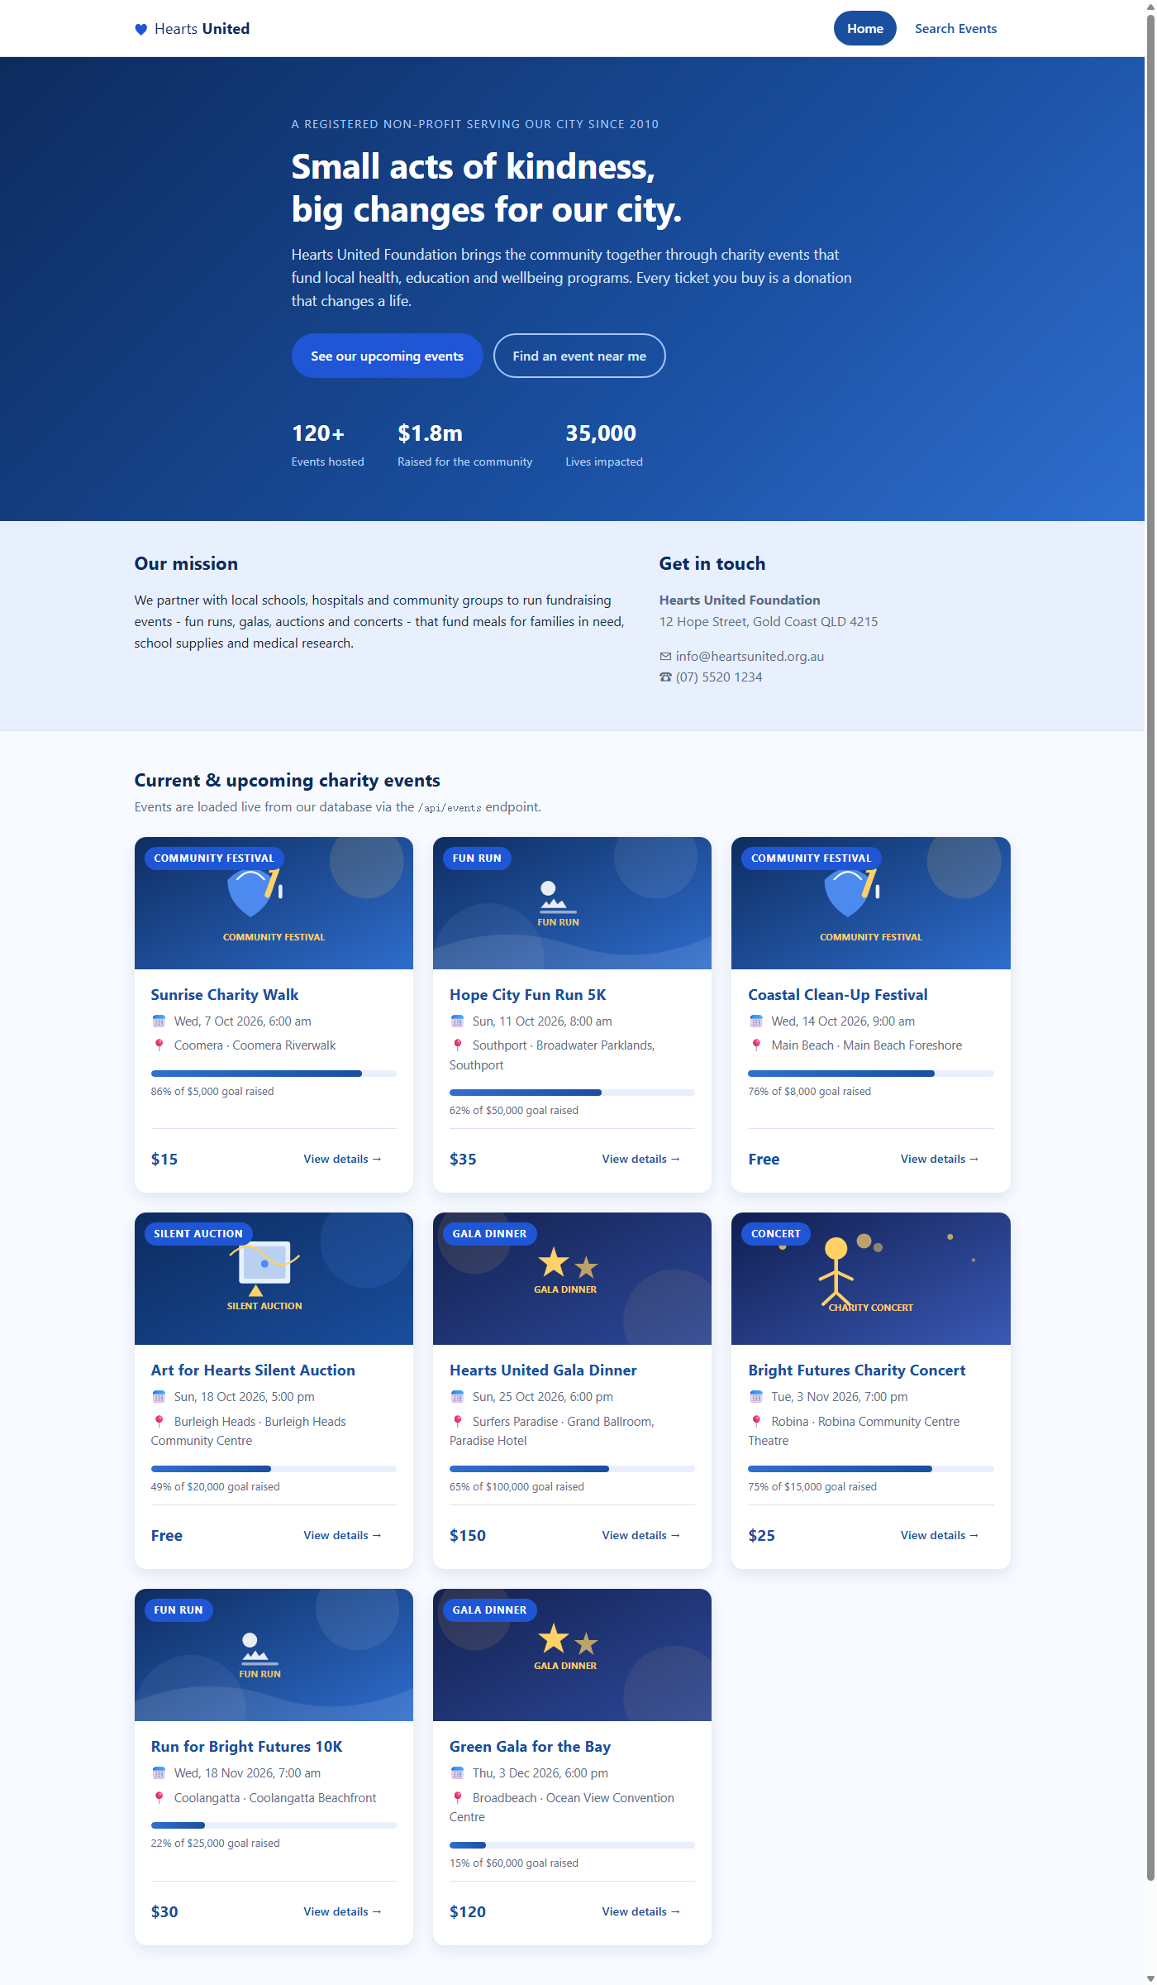
Search page - the filter form (date picker, location, category dropdown populated from GET /api/categories) with the Search and Clear Filters buttons:
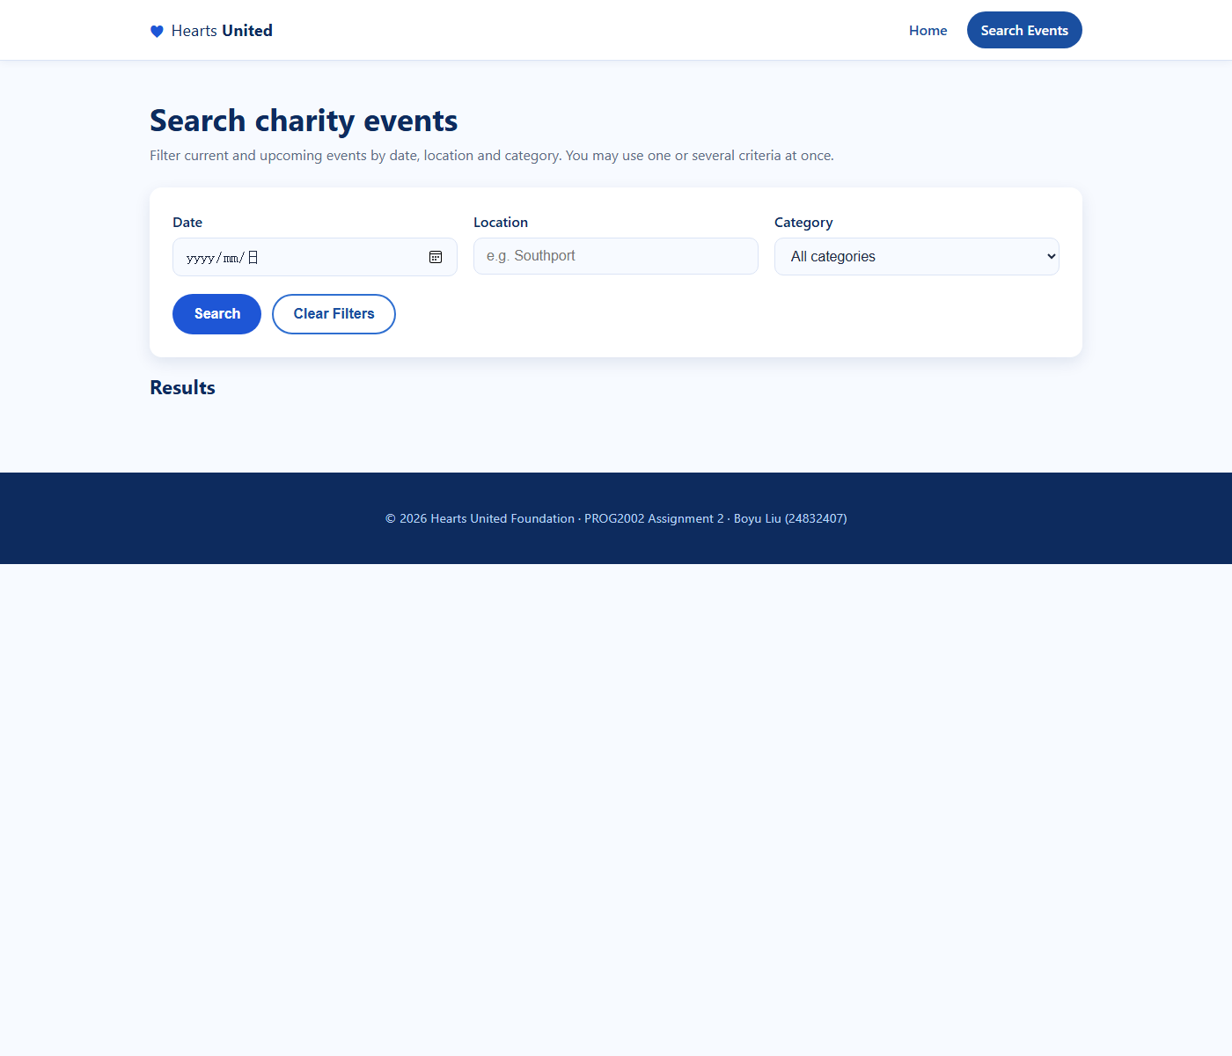
Event details page - event.html?id=2 showing the full details, the goal-versus-progress bar and the Register button:
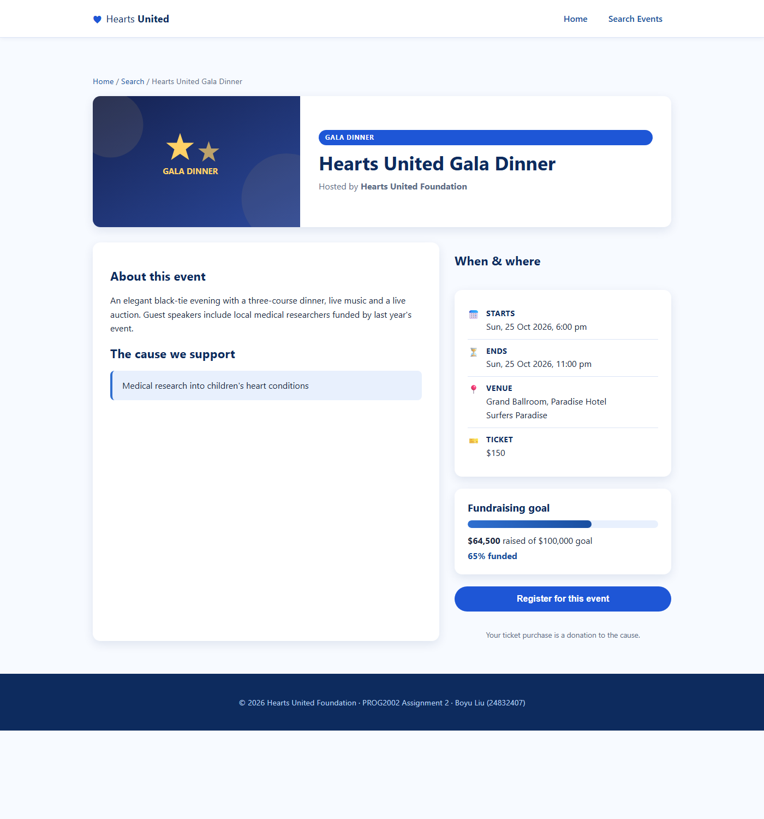
Register dialog - clicking the Register button opens a modal stating that the feature is currently under construction (implementation is part of Assessment 3):
